**UNIT – V**

Methods of Comparison of Alternatives–Present Worth Method of Comparison ( Revenue Dominated Cash flow Diagram, Cost Dominated Cash Flow Diagram),Future Worth Method Comparison (Revenue Dominated Cash Flow Diagram, Cost Dominated Cash Flow Diagram), Annual Equivalent Method of Comparison (Revenue Dominated Cash Flow Diagram, Cost Dominated Cash Flow Diagram), Rate of Return Method, Examples in all the methods.

# BASES FOR COMPARISON OF ALTERNATIVES

In most of the practical decision environments, executives will be forced to select the best alternative from a set of competing alternatives. Let us assume that an organization has a huge sum of money for potential investment and there are three different projects whose initial outlay and annual revenues during their lives are known. The executive has to select the best alternative among these three competing projects

There are several bases for comparing the worthiness of the projects. These bases are:

1. Present worth method
2. Future worth method
3. Annual equivalent method
4. Rate of return method

# PRESENT WORTH METHOD OF COMPARISON

**INTRODUCTION**

In this method of comparison, the cash flows of each alternative will be reduced to time zero by assuming an interest rate *i*. Then, depending on the type of decision, the best alternative will be selected by comparing the present worth amounts of the alternatives.

The sign of various amounts at different points in time in a cash flow diagram is to be decided based on the type of the decision problem. In a cost dominated cash flow diagram, the costs (outflows) will be assigned with positive sign and the profit, revenue, salvage value (all inflows), etc. will be assigned with negative sign. In a revenue/profit-dominated cash flow diagram, the profit, revenue, salvage value (all inflows to an organization) will be assigned with positive sign. The costs (outflows) will be assigned with negative sign.

In case the decision is to select the alternative with the minimum cost, then the alternative with the least present worth amount will be selected. On the other hand, if the decision is to select the alternative with the maximum profit, then the alternative with the maximum present worth will be selected.

2

# REVENUE-DOMINATED CASH FLOW DIAGRAM

A generalized revenue-dominated cash flow diagram to demonstrate the present worth method of comparison is presented in Fig. 4.1.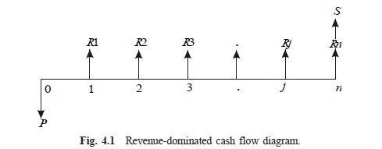

In Fig. 4.1, *P* represents an initial investment and *Rj* the net revenue at the end of the *j*th year. The interest rate is *i*, compounded annually. *S* is the salvagevalue at the end of the *n*th year.

To find the present worth of the above cash flow diagram for a given Interest rate, the formula is

*PW*(*i*) = – *P* + *R*1[1/(1 + *i*)1] + *R*2[1/(1 + *i*)2] + ...

+ *Rj*[1/(1 + *i*) *j*] + *Rn*[1/(1 + *i*)*n*] + *S*[1/(1 + *i*)*n*]

In this formula, expenditure is assigned a negative sign and revenues are assigned a positive sign.

If we have some more alternatives which are to be compared with this alternative, then the corresponding present worth amounts are to be computed and compared. Finally the alternative with the maximum present worth amount should be selected as the best alternative.

# COST-DOMINATED CASH FLOW DIAGRAM

A generalized cost-dominated cash flow diagram to demonstrate the present worth method of comparison is presented in Fig. 4.2.

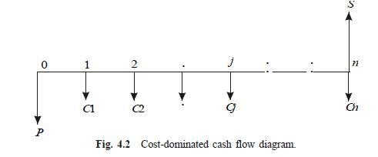

In Fig. 4.2, *P* represents an initial investment, *Cj* the net cost of operation and maintenance at the end of the *j*th year, and *S* the salvage value at the end of the *n*th year.

To compute the present worth amount of the above cash flow diagram for a given interest rate *i*, we have the formula

*PW*(*i*) = *P* + *C*1[1/(1 + *i*)1] + *C*2[1/(1 + *i*)2] + ... + *Cj*[1/(1 + *i*) *j*] +

*Cn*[1/(1 + *i*)*n*] – *S*[1/(1 + *i*)*n*]

In the above formula, the expenditure is assigned a positive sign and the revenue a negative sign. If we have some more alternatives which are to be compared with this alternative, then the corresponding present worth amounts are to be computed and compared. Finally, the alternative with the minimum present worth amount should be selected as the best alternative.

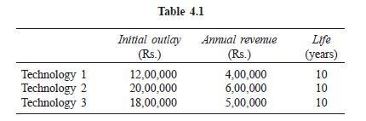***EXAMPLE 4.1*** Alpha Industry is planning to expand its production operation.It has identified three different technologies for meeting the goal. The initialoutlay and annual revenues with respect to each of the technologies aresummarized in Table 4.1. Suggest the best technology which is to be implemented based on the present worth method of comparison assuming 20% interest rate, compounded annually.

***Solution*** In all the technologies, the initial outlay is assigned a negative sign and the annual revenues are assigned a positive sign.

TECHNOLOGY 1

Initial outlay, *P* = Rs. 12,00,000 Annual revenue, *A* = Rs. 4,00,000 Interest rate, *i* = 20%,

compounded annually Life of this technology, *n* = 10 years

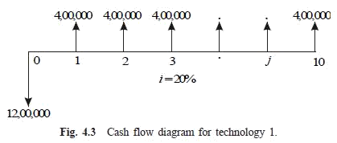The cash flow diagram of this technology is as shown in Fig. 4.3.

The present worth expression for this technology is

*PW*(20%)1 = –12,00,000 + 4,00,000 x (*P*/*A*, 20%, 10)

= –12,00,000 + 4,00,000 x (4.1925)

= –12,00,000 + 16,77,000

= Rs. 4,77,000

TECHNOLOGY 2

Initial outlay, *P* = Rs. 20,00,000 Annual revenue, *A* = Rs. 6,00,000

Interest rate, *i* = 20%, compounded annually Life of this technology, *n* = 10 years

The cash flow diagram of this technology is shown in Fig. 4.4.

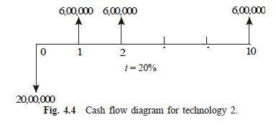

The present worth expression for this technology is

*PW*(20%)2 = – 20,00,000 + 6,00,000 x (*P*/*A*, 20%, 10)

= – 20,00,000 + 6,00,000 x (4.1925)

= – 20,00,000 + 6,00,000 x(4.1925)

= – 20,00,000 + 25,15,500

= Rs. 5,15,500

TECHNOLOGY 3

Initial outlay, *P* = Rs. 18,00,000 Annual revenue, *A* = Rs. 5,00,000

Interest rate, *i* = 20%, compounded annually Life of this technology, *n* = 10 years

The cash flow diagram of this technology is shown in Fig. 4.5

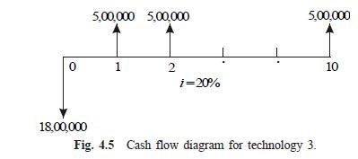

The present worth expression for this technology is

*PW*(20%)3 = –18,00,000 + 5,00,000 x (*P*/*A*, 20%, 10)

= –18,00,000 + 5,00,000 x(4.1925)

= –18,00,000 + 20,96,250

= Rs. 2,96,250

From the above calculations, it is clear that the present worth of technology 2 is the highest among all the technologies. Therefore, technology 2 is suggested for implementation to expand the production.

***EXAMPLE 4.2*** An engineer has two bids for an elevator to be installed in a new building. The details of the bids for the elevators are as follows:

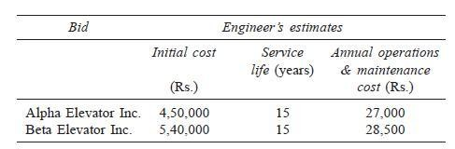

Determine which bid should be accepted, based on the present worth method of comparison assuming 15% interest rate, compounded annually.

***Solution***

# Bid 1: Alpha Elevator Inc.

Initial cost, *P* = Rs. 4,50,000

Annual operation and maintenance cost, *A* = Rs. 27,000 Life = 15 years

Interest rate, *i* = 15%, compounded annually

The cash flow diagram of bid 1 is shown in Fig. 4.6.

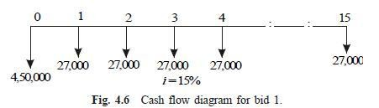

The present worth of the above cash flow diagram is computed as follows:

*PW*(15%) = 4,50,000 + 27,000(*P*/*A*, 15%, 15)

= 4,50,000 + 27,000 x 5.8474

= 4,50,000 + 1,57,879.80

= Rs. 6,07,879.80

# Bid 2: Beta Elevator Inc.

Initial cost, *P* = Rs. 5,40,000

Annual operation and maintenance cost, *A* = Rs. 28,500 Life = 15 years

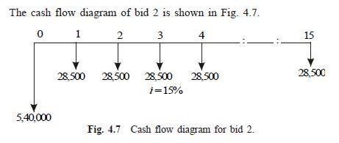Interest rate, *i* = 15%, compounded annually.

The present worth of the above cash flow diagram is computed as follows:

*PW*(15%) = 5,40,000 + 28,500(*P*/*A*, 15%, 15)

= 5,40,000 + 28,500 x 5.8474

= 5,40,000 + 1,66,650.90

= Rs. 7,06,650.90

The total present worth cost of bid 1 is less than that of bid 2. Hence, bid 1 is to be selected for implementation. That is, the elevator from Alpha Elevator Inc. is to be purchased and installed in the new building.

***EXAMPLE 4.3*** Investment proposals A and B have the net cash flows as follows:

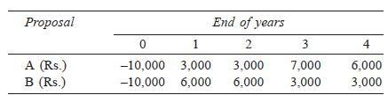

Compare the present worth of A with that of B at *i* = 18%. Which proposal should be selected?

## Solution

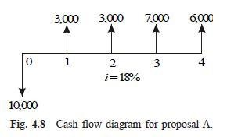**Present worth of A at *i* = 18%.** The cash flow diagram of proposal A is shown in Fig. 4.8.

The present worth of the above cash flow diagram is computed as

*PW*A(18%) = –10,000 + 3,000(*P*/*F*, 18%, 1) + 3,000(*P*/*F*, 18%, 2)

+ 7,000(*P*/*F*, 18%, 3) + 6,000(*P*/*F*, 18%, 4)

= –10,000 + 3,000 (0.8475) + 3,000(0.7182) + 7,000(0.6086)

+ 6,000(0.5158)

= Rs. 2,052.10

**Present worth of B at *i* = 18%.** The cash flow diagram of the proposal B is shown in Fig. 4.9.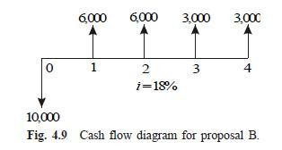

The present worth of the above cash flow diagram is calculated as

*PW*B(18%) = –10,000 + 6,000(*P*/*F*, 18%, 1) + 6,000(*P*/*F*, 18%, 2) +3,000(*P*/*F*, 18%, 3) +

3,000(*P*/*F*, 18%, 4)

= –10,000 + 6,000(0.8475) + 6,000(0.7182) + 3,000(0.6086) +3,000(0.5158)

= Rs. 2,767.40

At *i* = 18%, the present worth of proposal B is higher than that of proposal A. Therefore, select proposal B.

***EXAMPLE 4.4*** A granite company is planning to buy a fully automated granite cutting machine. If it is purchased under down payment, the cost of the machine is Rs. 16,00,000. If it is purchased under installment basis, the company has to pay 25% of the cost at the time of purchase and the remaining amount in 10 annual equal installments of Rs. 2,00,000 each. Suggest the best alternative for the company using the present worth basis at *i* = 18%, compounded annually.

***Solution*** There are two alternatives available for the company:

1. Down payment of Rs. 16,00,000
2. Down payment of Rs. 4,00,000 and 10 annual equal installments of Rs. 2,00,000 each

**Present worth calculation of the second alternative.** The cash flow diagram of the second alternative is shown in Fig. 4.10.

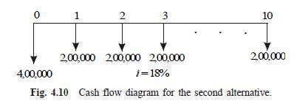

The present worth of the above cash flow diagram is computed as

*PW*(18%) = 4,00,000 + 2,00,000(*P*/*A*, 18%, 10)

= 4,00,000 + 2,00,000 x 4.4941

= Rs. 12,98,820

The present worth of this option is Rs. 12,98,820, which is less than the first option of complete down payment of Rs. 16,00,000. Hence, the company should select the second alternative to buy the fully automated granite cutting machine.

***EXAMPLE 4.5*** A finance company advertises two investment plans. In plan 1, the company pays Rs. 12,000 after 15 years for every Rs. 1,000 invested now. In plan 2, for every Rs. 1,000 invested, the company pays Rs. 4,000 at the end of the 10th year and Rs. 4,000 at the end of 15th year. Select the best investment plan from the investor‗s point of view at *i* = 12%, compounded annually.

***Solution*** *Plan 1.* The cash flow diagram for plan 1 is illustrated in Fig. 4.11.

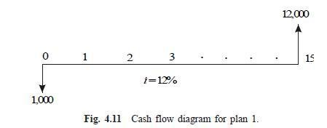

The present worth of the above cash flow diagram is calculated as

*PW*(12%) = –1,000 + 12,000(*P*/*F*, 12%, 15)

= –1,000 + 12,000(0.1827)

= Rs. 1,192.40

*Plan 2.* The cash flow diagram for plan 2 is shown in Fig. 4.12.

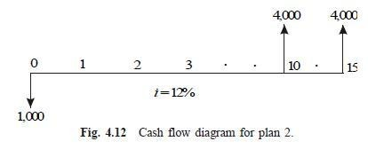

The present worth of the above cash flow diagram is computed as

*PW*(12%) = –1,000 + 4,000(*P*/*F*, 12%, 10) + 4,000(*P*/*F*, 12%, 15)

= –1,000 + 4,000(0.3220) + 4,000(0.1827)

= Rs. 1,018.80

The present worth of plan 1 is more than that of plan 2. Therefore, plan 1 is the best plan from the investor‗s point of view.

***EXAMPLE 4.6*** Novel Investment Ltd. accepts Rs. 10,000 at the end of every year for 20 years and pays the investor Rs. 8,00,000 at the end of the 20th year. Innovative Investment Ltd. accepts Rs. 10,000 at the end of every year for 20 years and pays the investor Rs. 15,00,000 at the end of the 25th year. Which is the best investment alternative? Use present worth base with *i* = 12%

## Solution

*Novel Investment Ltd’s plan.*

The cash flow diagram of Novel Investment Ltd‗s plan is shown in Fig. 4.13.

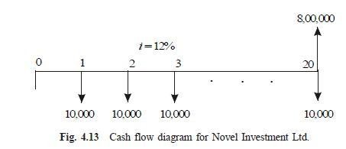

The present worth of the above cash flow diagram is computed as

*PW*(12%) = –10,000(*P*/*A*, 12%, 20) + 8,00,000(*P*/*F*, 12%, 20)

= –10,000(7.4694) + 8,00,000(0.1037)

= Rs. 8,266

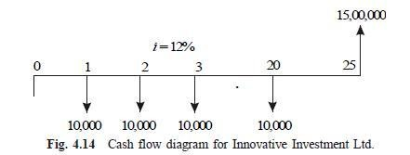*Innovative Investment Ltd’s plan.* The cash flow diagram of the Innovative Investment Ltd‗s plan is illustrated in Fig. 4.14.

The present worth of the above cash flow diagram is calculated as

*PW*(12%) = –10,000(*P*/*A*, 12%, 20) + 15,00,000(*P*/*F*, 12%, 25)

= –10,000(7.4694) + 15,00,000(0.0588)

= Rs. 13,506

The present worth of Innovative Investment Ltd‗s plan is more than that of Novel Investment Ltd‗s plan. Therefore, Innovative Investment Ltd‗s plan is the best from investor‗s point of view.

***EXAMPLE 4.7*** A small business with an initial outlay of Rs. 12,000 yields Rs. 10,000 during the first year of its operation and the yield increases by Rs. 1,000 from its second year of operation up to its 10th year of operation. At the end of the life of the business, the salvage value is zero. Find the present worth of the business by assuming an interest rate of 18%, compounded annually.

Solution

Initial investment, *P* = Rs. 12,000

Income during the first year, *A* = Rs. 10,000 Annual increase in income, *G* = Rs. 1,000 *n* = 10 years

*i* = 18%, compounded annually

The cash flow diagram for the small business is depicted in Fig. 4.15.

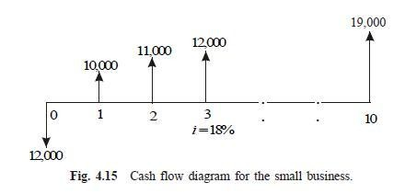

The equation for the present worth is

*PW*(18%) = –12,000 + (10,000 + 1,000 x (*A*/*G*, 18%, 10)) x (*P*/*A*, 18%, 10)

= –12,000 + (10,000 + 1,000 x 3.1936) x4.4941

= –12,000 + 59,293.36

= Rs. 47,293.36

The present worth of the small business is Rs. 47,293.36.

**FUTURE WORTH METHOD**

**INTRODUCTION**

In the future worth method of comparison of alternatives, the future worth of various alternatives will be computed. Then, the alternative with the maximum future worth of net revenue or with the minimum future worth of net cost will be selected as the best alternative for implementation.

# REVENUE-DOMINATED CASH FLOW DIAGRAM

A generalized revenue-dominated cash flow diagram to demonstrate the future worth method of comparison is presented in Fig. 5.1.

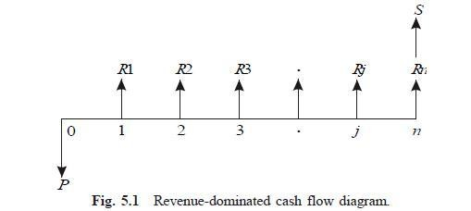

In Fig. 5.1, *P* represents an initial investment, *Rj* the net-revenue at the end of the

*j*th year, and *S* the salvage value at the end of the *n*th year.

The formula for the future worth of the above cash flow diagram for a given interest rate, *i* is

*FW*(*i*) = –*P*(1 + *i*)*n* + *R*1(1 + *i*)*n*–1 + *R*2(1 + i)*n*–2 + ...+ *Rj*(1 + *i*)*n*–*j* + ... + *Rn* + *S*

In the above formula, the expenditure is assigned with negative sign and the revenues are assigned with positive sign. If we have some more alternatives which are to be compared with this alternative, then the corresponding future worth amounts are to be computed and compared. Finally, the alternative with the maximum future worth amount should be selected as the best alternative.

# COST-DOMINATED CASH FLOW DIAGRAM

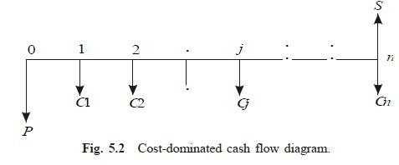A generalized cost-dominated cash flow diagram to demonstrate the future worth method of comparison is given in Fig. 5.2. In Fig. 5.2, *P* represents an initial investment, *Cj* the net cost of operation and maintenance at the end of the *j*th year, and *S* the salvage value at the end of the *n*th year.The formula for the future worth of the above cash flow diagram for a given interest rate, *i* is

*FW*(*i*) = *P*(1 + *i*)*n* + *C*1(1 + *i* )*n*–1 + *C*2(1 + *i*)*n*–2 + ...+ *Cj*(1 + *i*)*n–j* + ... + *Cn* – *S*

In this formula, the expenditures are assigned with positive sign and revenues with negative sign. If we have some more alternatives which are to be compared with this alternative, then the corresponding future worth amounts are to be computed and compared. Finally, the alternative with the minimum future worth amount should be selected as the best alternative.

# 5.4 EXAMPLES

In this section, several examples highlighting the applications of the future worth method of comparison are presented.

14

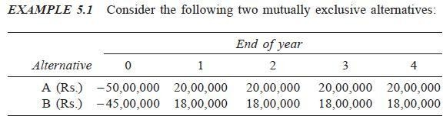

At *i* = 18%, select the best alternative based on future worth method of comparison.

***Solution Alternative A***

Initial investment, *P* = Rs. 50,00,000

Annual equivalent revenue, *A* = Rs. 20,00,000 Interest rate, *i* = 18%, compounded annually Life of alternative A = 4 years

The cash flow diagram of alternative A is shown in Fig. 5.3.

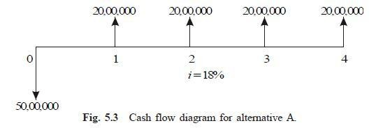

The future worth amount of alternative B is computed as

*FW*A(18%) = –50,00,000(*F*/*P*, 18%, 4) + 20,00,000(*F*/*A*, 18%, 4) = –

50,00,000(1.939) + 20,00,000(5.215)

= Rs. 7,35,000

***Alternative 2—*Build soft ice-cream stand**

First cost = Rs. 36,00,000

Net annual income = Annual income – Annual property tax

= Rs. 9,80,000 – Rs. 1,50,000

= Rs. 8,30,000

Life = 20 years

Interest rate = 12%, compounded annually

The cash flow diagram for this alternative is shown in Fig. 5.6.

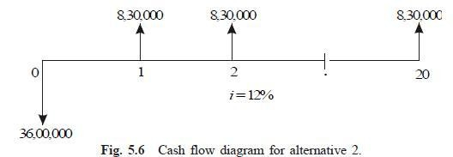

15

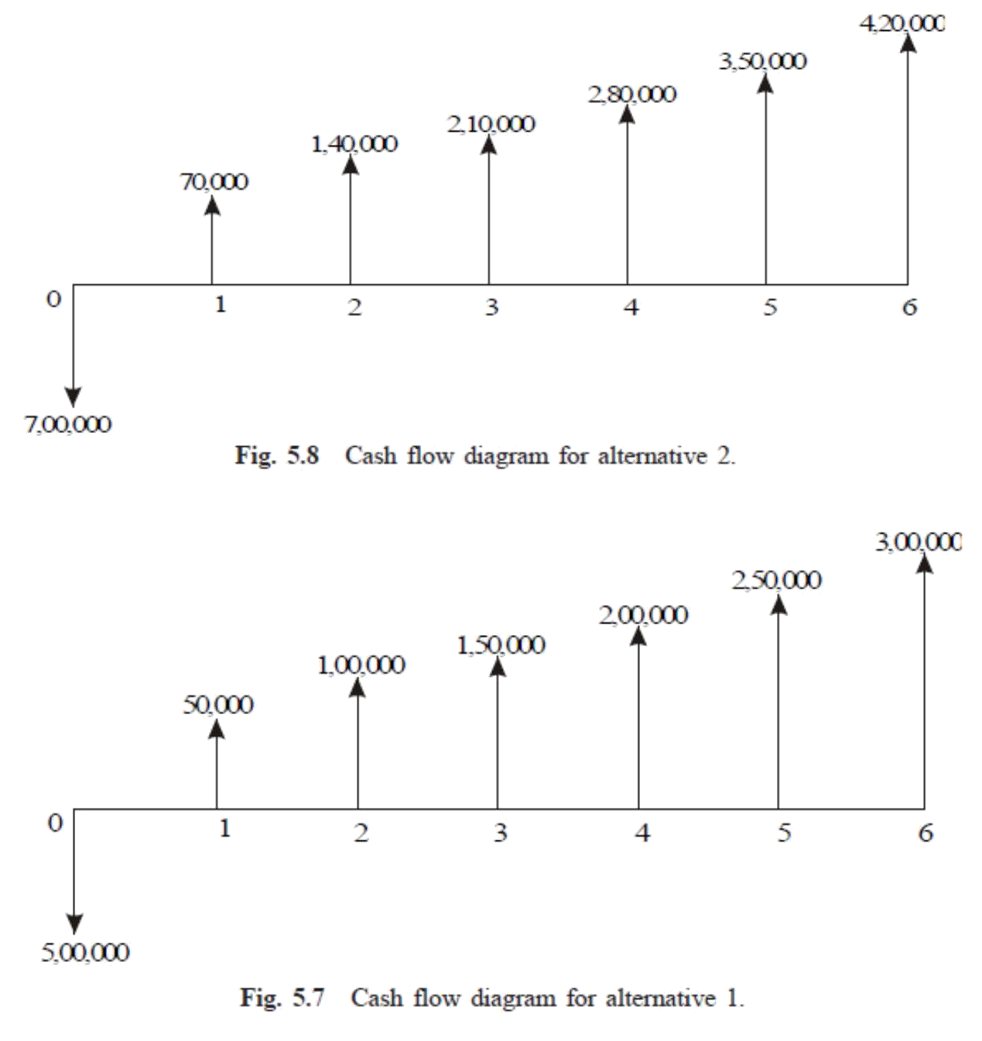

The future worth of alternative 2 is calculated as

*FW*2(12%) = – 36,00,000(*F*/*P*, 12%, 20) + 8,30,000 (*F*/*A*, 12%, 20)

= –36,00,000 (9.646) + 8,30,000 (72.052)

= Rs. 2,50,77,560

The future worth of alternative 1 is greater than that of alternative 2. Thus, building the gas station is the best alternative.

***EXAMPLE 5.3*** The cash flow diagram of two mutually exclusive alternatives are given in Figs. 5.7 and 5.8.

1. Select the best alternative based on future worth method at *i* = 8%.
2. Rework part (a) with *i* = 9% and 20%
3. ***Evaluation at*** *i = 8%*
4. ***Alternative 1***—**This comes under equal payment gradient series.**
5. *P* = Rs. 5,00,000 *A*1 = Rs. 50,000
6. *G* = Rs. 50,000
7. *i* = 8% *n* = 6 years

The formula for the future worth of alternative 1 is

*FW*1(8%) = –*P*(*F*/*P*, 8%, 6) + [*A*1 + *G*(*A*/*G*, 8%, 6)] x (*F*/*A*, 8%, 6)

= – 5,00,000(1.587) + [50,000 + 50,000(2.2764)] x 7.336

= – 79,35,000 + 1,63,820 x 7.336

= –79,35,000 + 12,01,784

= Rs. 4,08,283.52

***Alternative 2—*This comes under equal payment gradient series.**

*P* = Rs. 7,00,000 *A*1 = Rs. 70,000

*G* = Rs. 70,000

*i* = 8%

*n* = 6 years

The formula for the future worth of alternative 2 is

*FW*2(8%) = –*P*(*F*/*P*, 8%, 6) + [*A*1 + *G*(*A*/*G*, 8%, 6)] x (*F*/*A*, 8%, 6)

*FW*2(8%) = –7,00,000 x 1.587 + [70,000 + 70,000 x2.2764] x7.336

= –11,10,900 + 16,82,497

= Rs. 5,71,596.93

The future worth of alternative 2 is more than that of alternative 1. Therefore, alternative 2 must be selected.

***(f ) (i) Evaluation at*** *i = 9%:*

Alternative 1

*P* = Rs. 5,00,000 *A*1 = Rs. 50,000 *G* = Rs. 50,000 *n* = 6 years

The formula for the future worth of alternative 1 is as follows:

*FW*1(9%) = – *P*(*F*/*P*, 9%, 6) + [*A*1 + *G*(*A*/*G*, 9%, 6)] x (*F*/*A*, 9%, 6)

= – 5,00,000 (1.677) + [50,000 + 50,000 (2.2498)] x7.523

= – 8,38,500 + 12,22,412.27

= Rs. 3,83,912.27

## Alternative 2

*P* = Rs. 7,00,000 *A*1 = Rs. 70,000 *G* = Rs. 70,000 *n* = 6 years

The formula for the future worth of the alternative 2 is

*FW*2(9%) = –*P*(*F*/*P*, 9%, 6) + [*A*1 + *G*(*A*/*G*, 9%, 6)] x(*F*/*A*, 9%, 6)

= –7,00,000 x 1.677 + [70,000 + 70,000 x 2.2498] x 7.523

= –11,73,900 + 17,11,377.18

= Rs. 5,37,477.18

The future worth of alternative 2 is more than that of alternative 1. Therefore, alternative 2 must be selected

**(ii) Evaluation at** i = 20%: **Alternative 1**

P = Rs. 5,00,000 A1 = Rs. 50,000 G = Rs. 50,000 n = 6 years

The formula for the future worth of alternative 1 is

*FW*1(20%) = –*P*(*F*/*P*, 20%, 6) + [*A*1 + *G*(*A*/*G*, 20%, 6)] x(*F*/*A*, 20%, 6)

= –5,00,000(2.986) + [50,000 + 50,000 (1.9788)] x 9.93

= –14,93,000 + 14,78,974.20

= Rs. –14,025.80

The negative sign of the future worth amount indicates that alternative 1 incurs loss.

## Alternative 2

*P* = Rs. 7,00,000 *A*1 = Rs. 70,000 *G* = Rs. 70,000 *n* = 6 years

The formula for the future worth of alternative 2 is

*FW*2(20%) = – *P*(*F*/*P*, 20%, 6) + [*A*1 + *G*(*A*/*G*, 20%, 6)] _ (*F*/*A*, 20%, 6)

= –7,00,000 _ 2.986 + [70,000 + 70,000 _ 1.9788] _ 9.93

= –20,90,200 + 20,70,563.88

= Rs. –19,636.12

The negative sign of the above future worth amount indicates that alternative 2 incurs loss. Thus, none of the two alternatives should be selected.

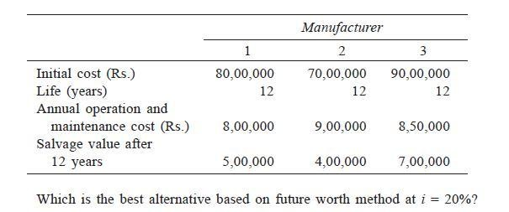***EXAMPLE 5.4*** M/S Krishna Castings Ltd. is planning to replace its annealing furnace. It has received tenders from three different original manufacturers of annealing furnace. The details are as follows.

# Solution Alternative 1—Manufacturer 1

First cost, P = Rs. 80,00,000 Life, n = 12 years

Annual operating and maintenance cost, *A* = Rs. 8,00,000 Salvage value at the end of furnace life = Rs. 5,00,000

The cash flow diagram for this alternative is shown in Fig. 5.9.

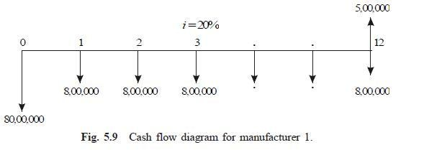

The future worth amount of alternative 1 is computed as

*FW*1(20%) = 80,00,000 (*F*/*P*, 20%, 12) + 8,00,000 (*F*/*A*, 20%, 12) – 5,00,000

= 80,00,000(8.916) + 8,00,000 (39.581) – 5,00,000

= Rs. 10,24,92,800

# Alternative 2— Manufacturer 2

20

First cost, P = Rs. 70,00,000 Life, n = 12 years

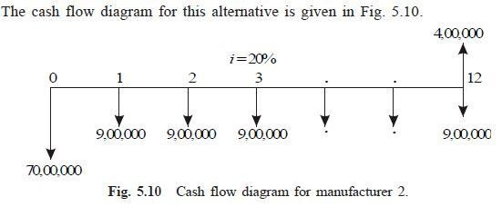Annual operating and maintenance cost, A = Rs. 9,00,000 Salvage value at the end of furnace life = Rs. 4,00,000

The future worth amount of alternative 2 is computed as

*FW*2(20%) = 70,00,000(*F*/*P*, 20%, 12) + 9,00,000(*F*/*A*, 20%, 12) – 4,00,000

= 70,00,000(8.916) + 9,00,000 (39.581) – 4,00,000

= Rs. 9,76,34,900

***Alternative 3—Manufacturer***

First cost, *P* = Rs. 90,00,000 Life, *n* = 12 years

Annual operating and maintenance cost, *A* = Rs. 8,50,000 Salvage value at the end of furnace life = Rs. 7,00,000

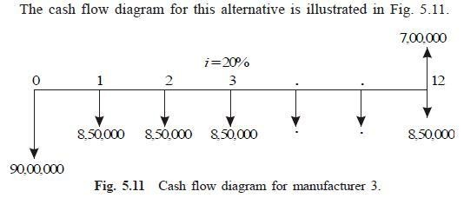

The future worth amount of alternative 3 is calculated as

*FW*3(20%) = 90,00,000(*F*/*P*, 20%, 12) + 8,50,000(*F*/*A*, 20%, 12) – 7,00,000

= 90,00,000(8.916) + 8,50,000 (39.581) – 7,00,000

= Rs. 11,31,87,850

The future worth cost of alternative 2 is less than that of the other two alternatives. Therefore, M/s. Krishna castings should buy the annealing furnace from manufacturer 2.

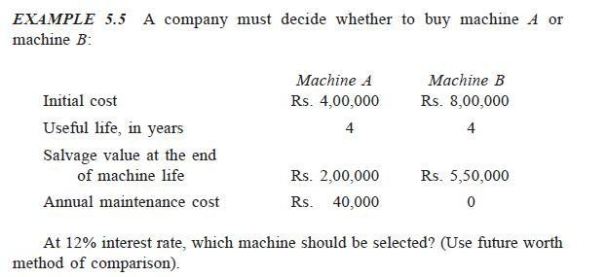

## Solution Machine A

Initial cost of the machine, *P* = Rs. 4,00,000 Life, *n* = 4 years

Salvage value at the end of machine life, *S* = Rs. 2,00,000 Annual maintenance cost, *A* = Rs. 40,000

Interest rate, *i* = 12%, compounded annually.

The cash flow diagram of machine *A* is given in Fig. 5.12.

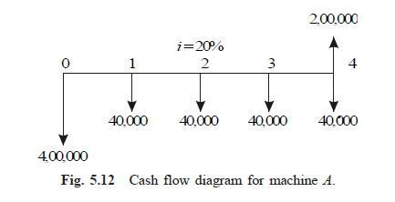

The future worth function of Fig. 5.12 is

*FWA*(12%) = 4,00,000 x (*F*/*P*, 12%, 4) + 40,000 x (*F*/*A*, 12%, 4) – 2,00,000

= 4,00,000 x (1.574) + 40,000 x (4.779) – 2,00,000

= Rs. 6,20,760

## Machine B

Initial cost of the machine, *P* = Rs. 8,00,000 Life, *n* = 4 years

Salvage value at the end of machine life, *S* = Rs. 5,50,000 Annual maintenance cost, *A* = zero.

Interest rate, *i* = 12%, compounded annually.

The cash flow diagram of the machine *B* is illustrated in Fig. 5.13.

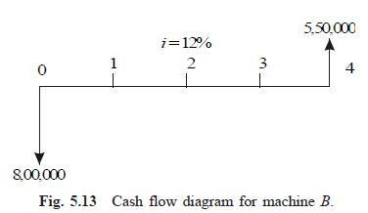

The future worth function of Fig 5.13 is

*FWB*(12%) = 8,00,000 x(*F*/*P*, 12%, 4) – 5,50,000

= 8,00,000 x (1.574) – 5,50,000

= Rs. 7,09,200

The future worth cost of machine *A* is less than that of machine *B*. Therefore, machine *A* should be selected.

# INTRODUCTION

**ANNUAL EQUIVALENT METHOD**

In the annual equivalent method of comparison, first the annual equivalent cost or the revenue of each alternative will be computed. Then the alternative with the maximum annual equivalent revenue in the case of revenue-based comparison or with the minimum annual equivalent cost in the case of costbased comparison will be selected as the best alternative.

# REVENUE-DOMINATED CASH FLOW DIAGRAM

A generalized revenue-dominated cash flow diagram to demonstrate the annual equivalent method of comparison is presented in Fig. 6.1.

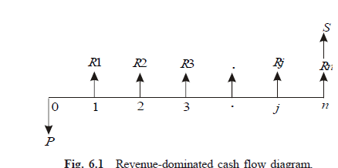

In Fig. 6.1, *P* represents an initial investment, *Rj* the net revenue at the end of the *j*th year, and *S* the salvage value at the end of the *n*th year.

The first step is to find the net present worth of the cash flow diagram using the following expression for a given interest rate, *i*:

*PW*(*i*) = –*P* + *R*1/(1 + *i*)1 + *R*2/(1 + *i*)2 + ...

+ *Rj*/(1 + *i*) *j* + ... + *Rn*/(1 + *i*)*n* + *S*/(1 + *i*)*n*

In the above formula, the expenditure is assigned with a negative sign and the revenues are assigned with a positive sign.

In the second step, the annual equivalent revenue is computed using the following formula:

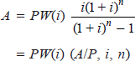

where (*A*/*P*, *i*, *n*) is called *equal payment series capital recovery factor*.

If we have some more alternatives which are to be compared with this alternative, then the corresponding annual equivalent revenues are to be computed and compared. Finally, the alternative with the maximum annual equivalent revenue should be selected as the best alternative.

# COST-DOMINATED CASH FLOW DIAGRAM

A generalized cost-dominated cash flow diagram to demonstrate the annual equivalent method of comparison is illustrated in Fig. 6.2.

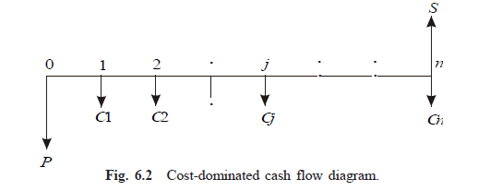

In Fig. 6.2, *P* represents an initial investment, *Cj* the net cost of operation and maintenance at the end of the *j*th year, and *S* the salvage value at the end of the *n*th year.

The first step is to find the net present worth of the cash flow diagram using the following relation for a given interest rate, *i*.

*PW*(*i*) = *P* + *C*1/(1 + *i*)1 + *C*2/(1 + *i*)2 + ...

+ *Cj*/(1 + *i*) *j* + ... + *Cn*/(1 + *i*)*n* – *S*/(1 + *i*)*n*

In the above formula, each expenditure is assigned with positive sign and the salvage value with negative sign. Then, in the second step, the annual equivalent cost is computed using the following equation:

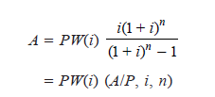

where (*A*/*P*, *i*, *n*) is called as equal-payment series capital recovery factor.

As in the previous case, if we have some more alternatives which are to be compared with this alternative, then the corresponding annual equivalent costsare to be computed and compared. Finally, the alternative with the minimum annual equivalent cost should be selected as the best alternative.

If we have some non-standard cash flow diagram, then we will have to follow the general procedure for converting each and every transaction to time zero and then convert the net present worth into an annual equivalent cost/ revenue depending on the type of the cash flow diagram. Such procedure is tobe applied to all the alternatives and finally, the best alternative is to be selected.

# ALTERNATE APPROACH

Instead of first finding the present worth and then figuring out the annual equivalent cost/revenue, an alternate method which is as explained below can be used. In each of the cases presented in Sections 6.2 and 6.3, in the first step, one can find the future worth of the cash flow diagram of each of the alternatives.

Then, in the second step, the annual equivalent cost/revenue can be obtained by using the equation:

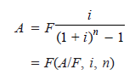 where (*A*/*F*, *i*, *n*) is called *equal-payment series sinking fund factor.*

# EXAMPLES

In this section, the application of the annual equivalent method is demonstrated with several numerical examples.

***EXAMPLE 6.1*** A company provides a car to its chief executive. The owner of the company is concerned about the increasing cost of petrol. The cost per litre of petrol for the first year of operation is Rs. 21. He feels that the cost of petrol will be increasing by Re.1 every year. His experience with his company car indicates that it averages 9 km per litre of petrol. The executive expects to drive an average of 20,000 km each year for the next four years. What is the annual equivalent cost of fuel over this period of time?. If he is offered similar service with the same quality on rental basis at Rs. 60,000 per year, should the owner continue to provide company car for his executive or alternatively provide a rental car to his executive? Assume *i* = 18%. If the rental car is preferred, then the company car will find some other use within the company

## Solution

Average number of km run/year = 20,000 km Number of km/litre of petrol = 9 km

Therefore,

Petrol consumption/year = 20,000/9 = 2222.2 litre Cost/litre of petrol for the 1st year = Rs. 21

Cost/litre of petrol for the 2nd year = Rs. 21.00 + Re. 1.00

= Rs. 22.00

Cost/litre of petrol for the 3rd year = Rs. 22.00 + Re. 1.00

= Rs. 23.00

Cost/litre of petrol for the 4th year = Rs. 23.00 + Re. 1.00

= Rs. 24.00

Fuel expenditure for 1st year = 2222.2 _ 21 = Rs. 46,666.20 Fuel expenditure for 2nd year = 2222.2 _ 22 = Rs. 48,888.40 Fuel expenditure for 3rd year = 2222.2 _ 23 = Rs. 51,110.60 Fuel expenditure for 4th year = 2222.2 _ 24 = Rs. 53,332.80

The annual equal increment of the above expenditures is Rs. 2,222.20 (*G*).

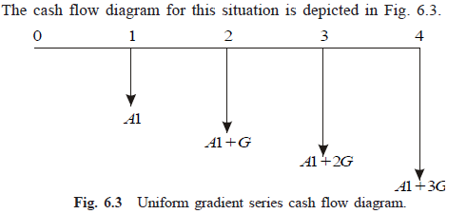

In Fig. 6.3, *A*1 = Rs. 46,666.20 and *G* = Rs. 2,222.20

*A* = *A*1 + *G*(*A*/*G*, 18%, 4)

= 46,666.20 + 2222.2(1.2947)

= Rs. 49,543.28

The proposal of using the company car by spending for petrol by the company will cost an annual equivalent amount of Rs. 49,543.28 for four years. This amount is less than the annual rental value of Rs. 60,000. Therefore, the company should continue to provide its own car to its executive.

***EXAMPLE 6.2*** A company is planning to purchase an advanced machine centre. Three original manufacturers have responded to its tender whose particulars are tabulated as follows:

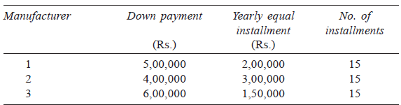

Determine the best alternative based on the annual equivalent method by assuming *i* = 20%, compounded annually.

## Solution Alternative 1

Down payment, *P* = Rs. 5,00,000

Yearly equal installment, *A* = Rs. 2,00,000

*n* = 15 years

*i* = 20%, compounded annually

The cash flow diagram for manufacturer 1 is shown in Fig. 6.4.

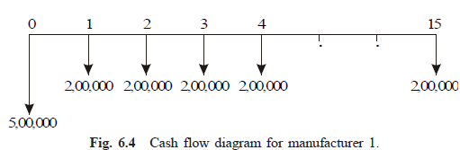

The annual equivalent cost expression of the above cash flow diagram is

*AE*1(20%) = 5,00,000(*A*/*P*, 20%, 15) + 2,00,000

= 5,00,000(0.2139) + 2,00,000

= 3,06,950 Alternative 2

Down payment, *P* = Rs. 4,00,000

Yearly equal installment, *A* = Rs. 3,00,000

*n* = 15 years

*i* = 20%, compounded annually

The cash flow diagram for the manufacturer 2 is shown in Fig. 6.5.

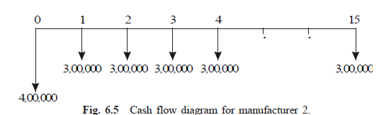The annual equivalent cost expression of the above cash flow diagram is

*AE*2(20%) = 4,00,000(*A*/*P*, 20%, 15) + 3,00,000

= 4,00,000(0.2139) + 3,00,000

= Rs. 3,85,560.

**Alternative 3**

Down payment, *P* = Rs. 6,00,000

Yearly equal installment, *A* = Rs. 1,50,000

*n* = 15 years

*i* = 20%, compounded annually

The cash flow diagram for manufacturer 3 is shown in Fig. 6.6.

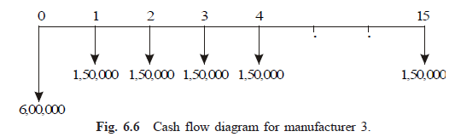

The annual equivalent cost expression of the above cash flow diagram is

*AE*3(20%) = 6,00,000(*A*/*P*, 20%, 15) + 1,50,000

= 6,00,000(0.2139) + 1,50,000

= Rs. 2,78,340.

The annual equivalent cost of manufacturer 3 is less than that of manufacturer 1 and manufacturer 2. Therefore, the company should buy the advanced machine centre from manufacturer 3.

***EXAMPLE 6.3*** A company invests in one of the two mutually exclusive alternatives. The life of both alternatives is estimated to be 5 years with the following investments, annual returns and salvage values.

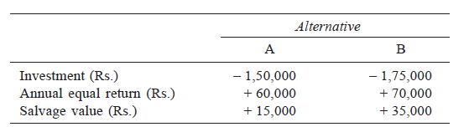

Determine the best alternative based on the annual equivalent method by assuming *i* = 25%.

## Solution Alternative A

Initial investment, *P* = Rs. 1,50,000 , Annual equal return, *A* = Rs. 60,000 Salvage value at the end of machine life, *S* = Rs. 15,000

Life = 5 years, Interest rate, *i* = 25%, compounded annually The cash flow diagram for alternative A is shown in Fig. 6.7.

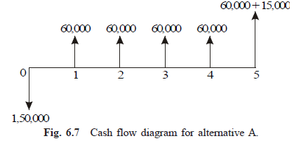

The annual equivalent revenue expression of the above cash flow diagram is as follows:

*AE*A(25%) = –1,50,000(*A*/*P*, 25%, 5) + 60,000 + 15,000(*A*/*F*, 25%, 5)

= –1,50,000(0.3718) + 60,000 + 15,000(0.1218)

= Rs. 6,057

## Alternative B

Initial investment, *P* = Rs. 1,75,000 Annual equal return, *A* = Rs. 70,000

Salvage value at the end of machine life, *S* = Rs. 35,000 Life = 5 years

Interest rate, *i* = 25%, compounded annually

The cash flow diagram for alternative B is shown in Fig. 6.8.

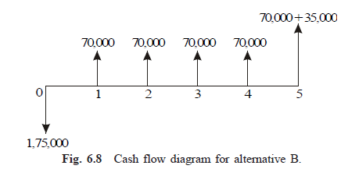

The annual equivalent revenue expression of the above cash flow diagram is

*AE*B(25%) = –1,75,000(*A*/*P*, 25%, 5) + 70,000 + 35,000(*A*/*F*, 25%, 5)

= –1,75,000(0.3718) + 70,000 + 35,000(0.1218)

= Rs. 9,198

The annual equivalent net return of alternative B is more than that of alternative A. Thus, the company should select alternative B.

***EXAMPLE 6.4*** A certain individual firm desires an economic analysis to determine which of the two machines is attractive in a given interval of time. The minimum attractive rate of return for the firm is 15%. The following data are to be used in the analysis:

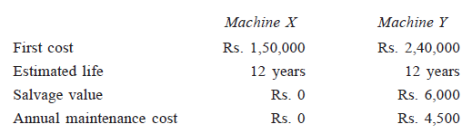

Which machine would you choose? Base your answer on annual equivalent cost.

## Solution Machine X

First cost, *P* = Rs. 1,50,000 Life, *n* = 12 years

Estimated salvage value at the end of machine life, *S* = Rs. 0. Annual maintenance cost, *A* = Rs. 0.

Interest rate, *i* = 15%, compounded annually.

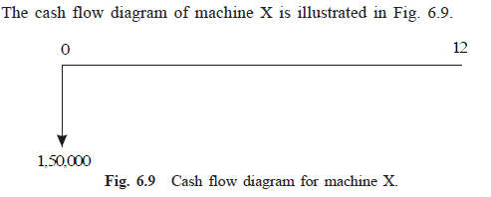

The annual equivalent cost expression of the above cash flow diagram is

*AE*X(15%) = 1,50,000(*A*/*P*, 15%, 12)

= 1,50,000(0.1845)

= Rs. 27,675

## Machine Y

First cost, *P* = Rs. 2,40,000 Life, *n* = 12 years

Estimated salvage value at the end of machine life, *S* = Rs. 60,000 Annual maintenance cost, *A* = Rs. 4,500

Interest rate, *i* = 15%, compounded annually.

The cash flow diagram of machine Y is depicted in Fig. 6.10.

The annual equivalent cost expression of the above cash flow diagram is

*AE*Y(15%) = 2,40,000(*A*/*P*, 15%, 12) + 4,500 – 6,000(*A*/*F*, 15%, 12)

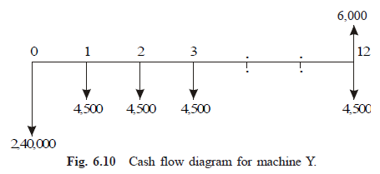= 2,40,000(0.1845) + 4,500 – 6,000(0.0345)

= Rs. 48,573

The annual equivalent cost of machine X is less than that of machine Y. So, machine X is the more cost effective machine.

***EXAMPLE 6.5*** Two possible routes for laying a power line are under study.Data on the routes are as follows:

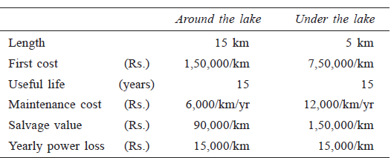

If 15% interest is used, should the power line be routed around the lake or under the lake?

## Solution Alternative 1— Around the lake

First cost = 1,50,000 x 15 = Rs. 22,50,000

Maintenance cost/yr = 6,000 x15 = Rs. 90,000 Power loss/yr = 15,000 x 15 = Rs. 2,25,000

Maintenance cost and power loss/yr = Rs. 90,000 + Rs. 2,25,000

= Rs. 3,15,000

Salvage value = 90,000 x 15 = Rs. 13,50,000

The cash flow diagram for this alternative is shown in Fig. 6.11

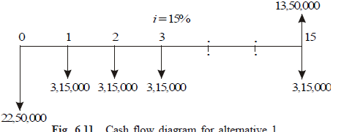

The annual equivalent cost expression of the above cash flow diagram is

*AE*1(15%) = 22,50,000(*A*/*P*, 15%, 15) + 3,15,000 – 13,50,000(*A*/*F*, 15%, 15)

= 22,50,000(0.1710) + 3,15,000 – 13,50,000(0.0210)

= Rs. 6,71,400

## Alternative 2—Under the lake

First cost = 7,50,000 x 5 = Rs. 37,50,000 Maintenance cost/yr = 12,000 x5 = Rs. 60,000 Power loss/yr = 15,000 x5 = Rs. 75,000

Maintenance cost and power loss/yr = Rs. 60,000 + Rs. 75,000

= Rs. 1,35,000

Salvage value = 1,50,000 x 5 = Rs. 7,50,000

The cash flow diagram for this alternative is shown in Fig. 6.12.

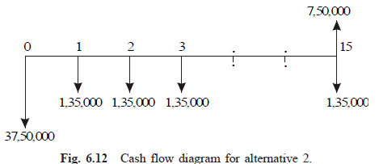The annual equivalent cost expression of the above cash flow diagram is

*AE*2(15%) = 37,50,000(*A*/*P*, 15%, 15) + 1,35,000 – 7,50,000(*A*/*F*, 15%, 15)

= 37,50,000(0.1710) + 1,35,000 – 7,50,000(0.0210)

= Rs. 7,60,500

The annual equivalent cost of alternative 1 is less than that of alternative 2. Therefore, select the route around the lake for laying the power line.

***EXAMPLE 6.6*** A suburban taxi company is analyzing the proposal of buying cars with diesel engines instead of petrol engines. The cars average 60,000 km a year with a useful life of three

years for the petrol taxi and four years for the diesel taxi. Other comparative details are as follows:

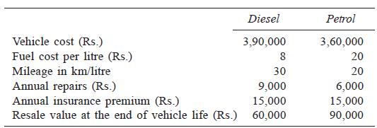

Determine the more economical choice if interest rate is 20%, compounded annually.

## Solution Alternative 1— Purchase of diesel taxi

Vehicle cost = Rs. 3,90,000 Life = 4 years

Number of litres/year 60,000/30 = 2,000 litres Fuel cost/yr = 2,000 x 8 = Rs. 16,000

Fuel cost, annual repairs and insurance premium/yr

= Rs. 16,000 + Rs. 9,000 + Rs. 15,000 = Rs. 40,000

Salvage value at the end of vehicle life = Rs. 60,000

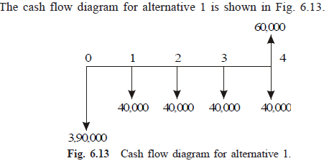 The annual equivalent cost expression of the above cash flow diagram is

*AE*(20%) = 3,90,000(*A*/*P*, 20%, 4) + 40,000 – 60,000(*A*/*F*, 20%, 4)

= 3,90,000(0.3863) + 40,000 – 60,000(0.1863)

= Rs. 1,79,479

## Alternative 2— Purchase of petrol taxi

Vehicle cost = Rs. 3,60,000

Life = 3 years, Number of litres/year 60,000/20 = 3,000 litres Fuel cost/yr = 3,000 x 20 = Rs. 60,000

Fuel cost, annual repairs and insurance premium/yr

= Rs. 60,000 + Rs. 6,000 + Rs. 15,000 = Rs. 81,000

Salvage value at the end of vehicle life = Rs. 90,000

The cash flow diagram for alternative 2 is shown in Fig. 6.14.

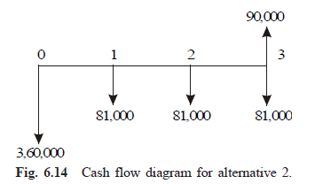

The annual equivalent cost expression of the above cash flow diagram is

*AE*(20%) = 3,60,000(*A*/*P*, 20%, 3) + 81,000 – 90,000(*A*/*F*, 20%, 3)

= 3,60,000(0.4747) + 81,000 – 90,000(0.2747)

= Rs. 2,27,169

The annual equivalent cost of purchase and operation of the cars with diesel engine is less than that of the cars with petrol engine. Therefore, the taxi company should buy cars with diesel engine. (*Note:* Comparison is done on common multiple lives of 12 years.)

***EXAMPLE 6.7*** Ramu, a salesman, needs a new car for use in his business. He expects that he will be promoted to a supervisory job at the end of third year and so his concern now is to have a car for the three years he expects to be ―on the road‖. The company will reimburse their

salesman each month the fuel cost and maintenance cost. Ramu has decided to drive a low-priced automobile. He finds, however, that there are two different ways of obtaining the automobile. In either case, the fuel cost and maintenance cost are borne by the company.

1. Purchase for cash at Rs. 3,90,000.
2. Lease a car. The monthly charge is Rs. 10,500 on a 36-month lease payable at the end of each month. At the end of the three-year period, the car is returned to the leasing company. Ramu believes that he should use a 12% interest rate compounded monthly in determining which alternative to select. If the car could be sold for Rs. 1,20,000 at the end of the third year, which option should he use to obtain it?

***Alternative 1—Purchase car for cash*** Purchase price of the car = Rs. 3,90,000 Life = 3 years = 36 months

Salvage value after 3 years = Rs. 1,20,000

Interest rate = 12% (nominal rate, compounded annually)

= 1% compounded monthly

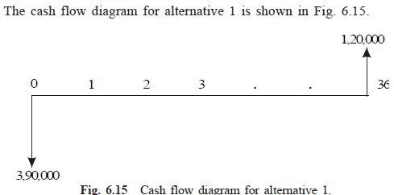

The monthly equivalent cost expression [*ME*(1%)] of the above cash flow diagram is

*ME*(1%) = 3,90,000(*A*/*P*, 1%, 36) – 1,20,000(*A*/*F*, 1%, 36)

= 3,90,000(0.0332) – 1,20,000(0.0232)

= Rs. 10,164

## Alternative 2—Use of car under lease

Monthly lease amount for 36 months = Rs. 10,500

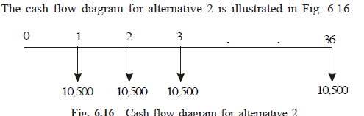

Monthly equivalent cost = Rs.10,500.

The monthly equivalent cost of alternative 1 is less than that of alternative 2. Hence, the salesman should purchase the car for cash.

***EXAMPLE 6.8*** A company must decide whether to buy machine A or machine B.

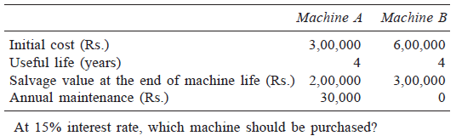

***Solution Machine A*** Initial cost = Rs. 3,00,000 Useful life (years) = 4

Salvage value at the end of machine life = Rs. 2,00,000 Annual maintenance = Rs. 30,000

Interest rate = 15%, compounded annually

The cash flow diagram of machine A is depicted in Fig. 6.17.

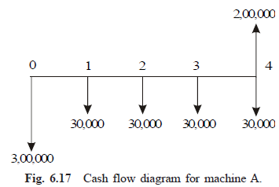

The annual equivalent cost expression of the above cash flow diagram is

*AE*(15%) = 3,00,000(*A*/*P*, 15%, 4) + 30,000 – 2,00,000(*A*/*F*, 15%, 4)

= 3,00,000(0.3503) + 30,000 – 2,00,000(0.2003)

= Rs. 95,030

## Machine B

Initial cost = Rs. 6,00,000 Useful life (years) = 4

Salvage value at the end of machine life = Rs. 3,00,000 Annual maintenance = Rs. 0.

Interest rate = 15%, compounded annually

The cash flow diagram of machine B is illustrated in Fig. 6.18.

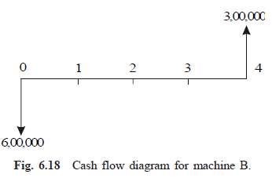

The annual equivalent cost expression of the above cash flow diagram is

*AE*(15%) = 6,00,000(*A*/*P*, 15%, 4) – 3,00,000(*A*/*F*, 15%, 4)

= 6,00,000(0.3503) – 3,00,000(0.2003)

= Rs. 1,50,090

Since the annual equivalent cost of machine A is less than that of machine B, it is advisable to buy machine A.

***EXAMPLE 6.9*** Jothi Lakshimi has arranged to buy some home recording equipment. She estimates that it will have a five year useful life and no salvage value at the end of equipment life. The dealer, who is a friend has offered Jothi Lakshimi two alternative ways to pay for the equipment.

1. Pay Rs. 60,000 immediately and Rs. 15,000 at the end of one year.
2. Pay nothing until the end of fourth year when a single payment of Rs. 90,000 must be made.

If Jothi Lakshimi believes 12% is a suitable interest rate, which alternative is the best for her?

## Solution Alternative 1

Down payment = Rs. 60,000 Payment after one year = Rs. 15,000

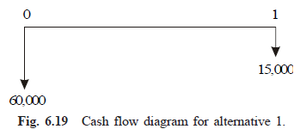The cash flow diagram for alternative 1 is shown in Fig. 6.19.

The present worth equation of the above cash flow diagram is

*PW*(12%) = 60,000 + 15,000(*P*/*F*, 12%, 1)

= 60,000 + 15,000(0.8929)

= 73,393.50

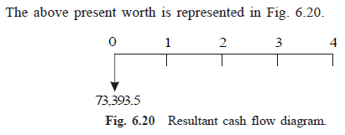

The annual equivalent expression of the above cash flow diagram is

*AE*(12%) = 73,393.5(*A*/*P*, 12%, 4)

= 73,393.5(0.3292)

= Rs. 24,161.14

## Alternative 2

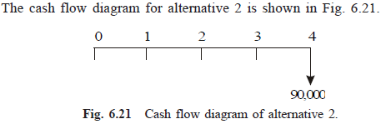Payment after four years = Rs. 90,000

The annual equivalent cost expression of the above cash flow diagram is

*AE*(12%) = 90,000(*A*/*F*, 12%, 4)

= 90,000(0.2092)

= Rs. 18,828

The annual equivalent cost of alternative 2 is less than that of alternative 1. Hence, Jothi Lakshimi should select alternative 2 for purchasing the home equipment.

***EXAMPLE 6.10*** A transport company has been looking for a new tyre for its truck and has located the following alternatives:

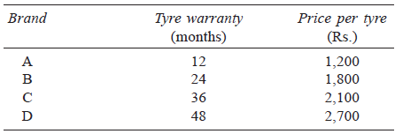

If the company feels that the warranty period is a good estimate of the tyre life and that a nominal interest rate (compounded annually) of 12% is appropriate, which tyre should it buy?

***Solution*** In all the cases, the interest rate is 12%. This is equivalent to 1% per month.

## Brand A

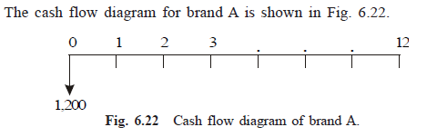Tyre warranty = 12 months Price/tyre = Rs. 1,200

The annual equivalent cost expression of the above cash flow diagram is

*AE*(1%) = 1,200(*A*/*P*, 1%, 12)

= 1,200(0.0888)

= Rs. 106.56

## Brand B

Tyre warranty = 24 months Price/tyre = Rs. 1,800

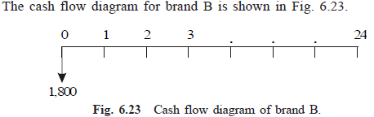 The annual equivalent cost expression of the above cash flow diagram is

*AE*(1%) = 1,800(*A*/*P*, 1%, 24)

= 1,800(0.0471)

= Rs. 84.78

## Brand C

Tyre warranty = 36 months Price/tyre = Rs. 2,100

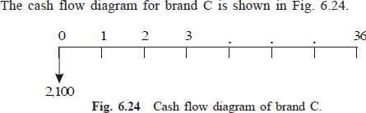

The annual equivalent expression of the above cash flow diagram is

*AE*(1%) = 2,100(*A*/*P*, 1%, 36)

= 2,100(0.0332)

= Rs. 69.72

## Brand D

Tyre warranty = 48 months Price/tyre = Rs. 2,700

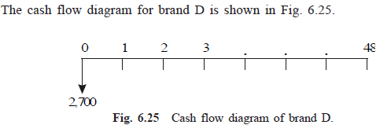

The annual equivalent cost expression of the above cash flow diagram is

*AE*(1%) = 2,700(*A*/*P*, 1%, 48)

= 2,700 (0.0263)

= Rs. 71.01

Here, minimum common multiple lives of tyres are considered. This is 144 months. Therefore, the comparison is made on 144 month‘s basis. The annual equivalent cost of brand C is less than that of other brands. Hence, it should be used in the vehicles of the trucking company. It should

be replaced four times during the 144-month period.

# RATE OF RETURN METHOD

**INTRODUCTION**

The rate of return of a cash flow pattern is the interest rate at which the present worth of that cash flow pattern reduces to zero. In this method of comparison, the rate of return for each alternative is computed. Then the alternative which has the highest rate of return is selected as the best alternative. In this type of analysis, the expenditures are always assigned with a negative sign and the revenues/inflows are assigned with a positive sign.

A generalized cash flow diagram to demonstrate the rate of return method of comparison is presented in Fig. 7.1.

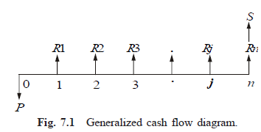

In the above cash flow diagram, *P* represents an initial investment, *Rj* the

net revenue at the end of the *j*th year, and *S* the salvage value at the end of the

*n*th year.

The first step is to find the net present worth of the cash flow diagram using the following expression at a given interest rate, *i*.

*PW*(*i*) = – *P* + *R*1/(1 + *i*)1 + *R*2/(1 + *i*)2 + ...

+ *Rj*/(1 + *i*) *j* + ... + *Rn*/(1 + *i*)*n* + *S*/(1 + *i*)*n*

Now, the above function is to be evaluated for different values of *i* until the present worth function reduces to zero, as shown in Fig. 7.2.

In the figure, the present worth goes on decreasing when the interest rate is increased. The value of *i* at which the present worth curve cuts the *X*-axis is the rate of return of the given

proposal/project. It will be very difficult to find the exact value of *i* at which the present worth function reduces to zero.

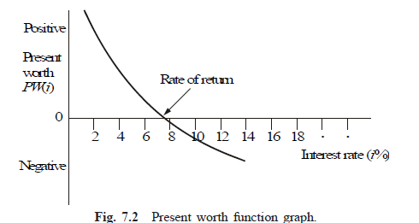

So, one has to start with an intuitive value of *i* and check whether the present worth function is positive. If so, increase the value of *i* until *PW*(*i*) becomes negative. Then, the rate of return is determined by interpolation method in the range of values of *i* for which the sign of the present worth function changes from positive to negative.

# EXAMPLES

In this section, the concept of rate of return calculation is demonstrated with suitable examples.

***EXAMPLE 7.1*** A person is planning a new business. The initial outlay and cash flow pattern for the new business are as listed below. The expected life of the business is five years. Find the rate of return for the new business.

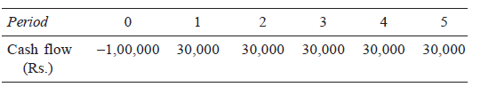

## Solution

Initial investment = Rs. 1,00,000 Annual equal revenue = Rs. 30,000 Life = 5 years

The cash flow diagram for this situation is illustrated in Fig. 7.3.

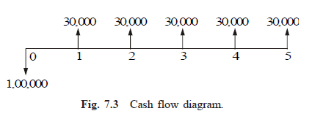

The present worth function for the business is

*PW*(*i*) = –1,00,000 + 30,000(*P*/*A*, *i*, 5)

When *i* = 10%,

*PW*(10%) = –1,00,000 + 30,000(*P*/*A*, 10%, 5)

= –1,00,000 + 30,000(3.7908)

= Rs. 13,724.

When *i* = 15%,

*PW*(15%) = –1,00,000 + 30,000(*P*/*A*, 15%, 5)

= –1,00,000 + 30,000(3.3522)

= Rs. 566.

When *i* = 18%,

*PW*(18%) = –1,00,000 + 30,000(*P*/*A*, 18%, 5)

= –1,00,000 + 30,000(3.1272)

= Rs. – 6,184

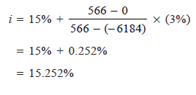Therefore, the rate of return for the new business is 15.252%.

***EXAMPLE 7.2*** A company is trying to diversify its business in a new product line. The life of the project is 10 years with no salvage value at the end of its life. The initial outlay of the project is Rs. 20,00,000. The annual net profit is Rs. 3,50,000. Find the rate of return for the new business.

## Solution

Life of the product line (*n*) = 10 years Initial outlay = Rs. 20,00,000

Annual net profit = Rs. 3,50,000 Scrap value after 10 years = 0

The cash flow diagram for this situation is shown in Fig. 7.4.

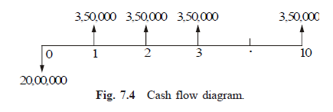The formula for the net present worth function of the situation is

*PW*(*i*) = –20,00,000 + 3,50,000(*P*/*A*, *i*, 10)

When *i* = 10%,

*PW*(10%) = –20,00,000 + 3,50,000(*P*/*A*, 10%, 10)

= –20,00,000 + 3,50,000(6.1446)

= Rs. 1,50,610.

When *i* = 12%,

*PW*(12%) = –20,00,000 + 3,50,000(*P*/*A*, 12%, 10)

= –20,00,000 + 3,50,000(5.6502)

= Rs. –22,430.

= 11.74 %

Therefore, the rate of return of the new product line is 11.74%

***EXAMPLE 7.3*** A firm has identified three mutually exclusive investment proposals whose details are given below. The life of all the three alternatives is estimated to be five years with negligible salvage value. The minimum attractive rate of return for the firm is 12%.

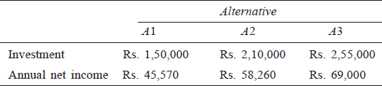

Find the best alternative based on the rate of return method of comparison.

## Solution

***Calculation of rate of return for alternative*** *A*1 Initial outlay = Rs. 1,50,000

Annual profit = Rs. 45,570 Life = 5 years

The cash flow diagram for alternative *A*1 is shown in Fig. 7.5.

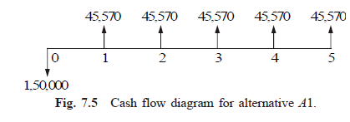The formula for the net present worth of alternative *A*1 is given as

*PW*(*i*) = –1,50,000 + 45,570(*P*/*A*, *i*, 5)

When *i* = 10%,

*PW*(10%) = –1,50,000 + 45,570(*P*/*A*, 10%, 5)

= –1,50,000 + 45,570(3.7908)

= Rs. 22,746.76

When *i* = 12%,

*PW*(12%) = –1,50,000 + 45,570(*P*/*A*, 12%, 5)

= –1,50,000 + 45,570(3.6048)

= Rs. 14,270.74

When *i* = 15%,

*PW*(15%) = –1,50,000 + 45,570(*P*/*A*, 15%, 5)

= –1,50,000 + 45,570(3.3522)

= Rs. 2,759.75

When *i* = 18%,

*PW*(18%) = –1,50,000 + 45,570(*P*/*A*, 18%, 5)

= –1,50,000 + 45,570(3.1272)

= Rs. –7,493.50

Therefore, the rate of return of the alternative *A*1 is

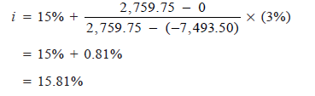 ***Calculation of rate of return for alternative***

*A*2 Initial outlay = Rs. 2,10,000

Annual profit = Rs. 58,260 Life of alternative *A*2 = 5 years

The cash flow diagram for alternative *A*2 is shown in Fig. 7.6.

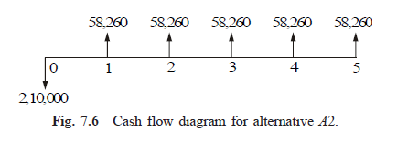

The formula for the net present worth of this alternative is

*PW*(*i*) = –2,10,000 + 58,260 (*P*/*A*, *i*, 5)

When *i* = 12%,

*PW*(12%) = –2,10,000 + 58,260(*P*/*A*, 12%, 5)

= –2,10,000 + 58,260(3.6048)

= Rs. 15.6

When *i* = 13%,

*PW*(13%) = –2,10,000 + 58,260(*P*/*A*, 13%, 5)

= –2,10,000 + 58,260 (3.5172)

= Rs. –5,087.93

Therefore, the rate of return of alternative *A*2 is

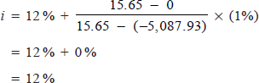

***Calculation of rate of return for alternative*** *A*3 Initial outlay = Rs. 2,55,000

Annual profit = Rs. 69,000 Life of alternative *A*3 = 5 years

The cash flow diagram for alternative *A*3 is depicted in Fig. 7.7.

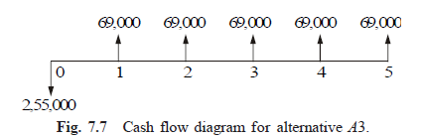

The formula for the net present worth of this alternative *A*3 is

*PW*(*i*) = –2,55,000 + 69,000(*P*/*A*, *i*, 5)

When *i* = 11%,

*PW*(11%) = – 2,55,000 + 69,000(*P*/*A*, 11%, 5)

= –2,55,000 + 69,000 (3.6959)

= Rs. 17.1

When *i* = 12%,

*PW*(12%) = – 2,55,000 + 69,000(*P*/*A*, 12%, 5)

= –2,55,000 + 69,000 (3.6048)

= Rs. – 6,268.80

Therefore, the rate of return for alternative *A*3 is

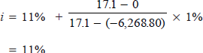

The rates of return for the three alternatives are now tabulated



From the above data, it is clear that the rate of return for alternative *A*3 is less than the minimum attractive rate of return of 12%. So, it should not be considered for comparison. The remaining two alternatives are qualified for consideration. Among the alternatives *A*1 and *A*2, the rate of return of alternative *A*1 is greater than that of alternative *A*2. Hence, alternative *A*1 should be selected.

***EXAMPLE 7.4*** For the cash flow diagram shown in Fig. 7.8, compute the rate of return. The amounts are in rupees. 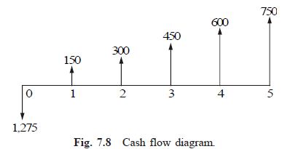

***Solution*** For the positive cash flows of the problem,

*A*1 = Rs. 150, *G* = Rs. 150

The annual equivalent of the positive cash flows of the uniform gradient series is given by

*A* = *A*1 + *G*(*A*/*G*, *i*, *n*)

= 150 + 150(*A*/*G*, *i*, 5)

The formula for the present worth of the whole diagram

= –1,275 + [150 + 150(*A*/*G*, *i*, 5)] _ (*P*/*A*, *i*, 5)

*PW*(10%) = –1,275 + [150 + 150(*A*/*G*, 10%, 5)] __ (*P*/*A*, 10%, 5)

= –1,275 + [150 + 150(1.8101)] _ (3.7908)

= Rs. 322.88

*PW*(12%) = –1,275 + [150 + 150(*A*/*G*, 12%, 5)] _ (*P*/*A*, 12%, 5)

= –1,275 + [150 + 150(1.7746)] _ (3.6048)

= Rs. 225.28

*PW*(15%) = –1,275 + [150 + 150(*A*/*G*, 15%, 5)] _ (*P*/*A*, 15%, 5)

= –1,275 + [150 + 150(1.7228)] _ (3.3522)

= Rs. 94.11

*PW*(18%) = –1,275 + [150 + 150(*A*/*G*, 18%, 5)] _ (*P*/*A*, 18%, 5)

= –1,275 + [150 + 150(1.6728)] _ (3.1272)

= Rs. –21.24

Therefore, the rate of return for the cash flow diagram is

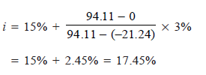

***EXAMPLE 7.5*** A company is planning to expand its present business activity. It has two alternatives for the expansion programme and the corresponding cash flows are tabulated below. Each alternative has a life of five years and a negligible salvage value. The minimum attractive rate of return for the company is 12%. Suggest the best alternative to the company.

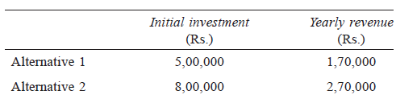

## Solution Alternative 1

Initial outlay = Rs. 5,00,000 Annual revenue = Rs. 1,70,000 Life of alternative 1 = 5 years

The cash flow diagram for alternative 1 is illustrated in Fig. 7.9.

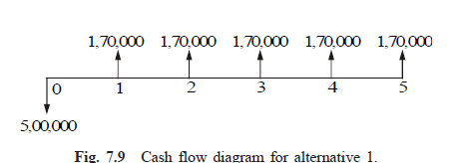

The formulae for the net present worth of alternative 1 are as follows:

*PW*1(*i*) = –5,00,000 + 1,70,000(*P*/*A*, *i*, 5)

*PW*1(15%) = –5,00,000 + 1,70,000(*P*/*A*, 15%, 5)

= –5,00,000 + 1,70,000(3.3522)

= Rs. 69,874

*PW*1(17%) = –5,00,000 + 1,70,000(*P*/*A*, 17%, 5)

= –5,00,000 + 1,70,000(3.1993)

= Rs. 43,881

*PW*1(20%) = –5,00,000 + 1,70,000(*P*/*A*, 20%, 5)

= –5,00,000 + 1,70,000(2.9906)

= Rs. 8,402

*PW*1(22%) = –5,00,000 + 1,70,000(*P*/*A*, 22%, 5)

= –5,00,000 + 1,70,000(2.8636)

= Rs. –13,188

Therefore, the rate of return of alternative 1 is

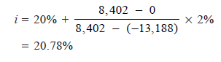

## Alternative 2

Initial outlay = Rs. 8,00,000 Annual revenue = Rs. 2,70,000 Life = 5 years

The cash flow diagram for alternative 2 is depicted in Fig. 7.10.

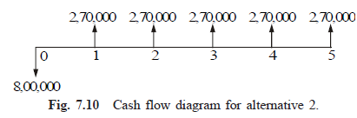

The formula for the net present worth of alternative 2 is:

*PW*2(*i*) = – 8,00,000 + 2,70,000(*P*/*A*, *i*, 5)

*PW*2(20%) = – 8,00,000 + 2,70,000(*P*/*A*, 20%, 5)

= – 8,00,000 + 2,70,000(2.9906)

= Rs. 7,462

*PW*2(22%) = –8,00,000 + 2,70,000 (*P*/*A*, 22%, 5)

= – 8,00,000 + 2,70,000 (2.8636)

= Rs. –26,828

Thus, the rate of return of alternative 2 is

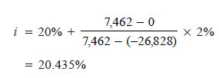

Since the rate of return of alternative 1 is greater than that of the alternative 2, select alternative 1.